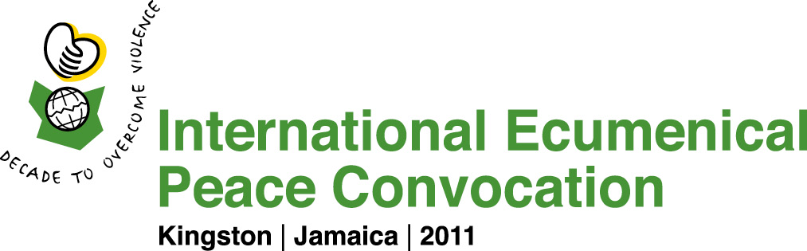

Application Form for Individuals Seeking to be a Part of the Course for Seminarians

This course is being sponsored by United Theological College of the West Indies, together with Boston University School of Theology in partnership with the Boston Theological Institute.

Details for this course, its cost, & process of selection are on the course syllabus.

Title First Name
Last Name
Street Address
City and Postcode
Country
Telephone Fax
E-mail

Name of school or organization you represent

Theme you are most interested in:

- Peace in the Community
- Peace with the Earth
- Peace in the Marketplace
- Peace among the Peoples

Brief description (100 words) of present position and/or involvement in relation to peace concerns.

Brief description (100 words) of what contribution you can bring to the IEPC and how you can spread the IEPC message upon return to your home setting.

Please tick each of the boxes that apply

Woman Ordained Youth (between 18 and 30 at time of IEPC)

Please return this form by 1 April 2011 by e-mail to: petersen@bostontheological.org

