Youth Internship Programme

An ecumenical experience
for young people

World Council of Churches
Geneva, Switzerland
February 2010 - January 2011


The World Council of Churches welcomes five young people (aged 18-30 years) to serve as interns in its Geneva offices. We look for Interns who are committed to the ideals of the ecumenical movement, to bring their energy, commitment and fresh vision to a specific work assignment. For the WCC, interns represent the potential of the ecumenical movement, and its search for a renewed vocation. Interns bring valuable experiences to the WCC at the same time as they go through several modules of ecumenical learning. The WCC Internships Programme prepares young people to continue their ecumenical involvement beyond the internship.

The WCC Youth Internship period is for 12 months from February 2010 to January 2011. In Geneva, the interns are assigned a task within one of the WCC working areas. They carry out their tasks in co-operation with programme staff, one of whom will supervise each intern. Each intern is then expected to plan an ecumenical project during their stay in Geneva and then implement this project starting from February 2011 in their home context. The local ecumenical project is a critical aspect of the WCC internship program to ensure that the intern can share his/her ecumenical experience and expertise with their church and community. Intern applicants must send along with their application, an application from their sending organization, church or Christian youth network to ensure accountability that the ecumenical project will be carried out with support from the local, national or regional contacts.

General Qualifications for interns:
- Between 18 to 30 years of age at the time the Internship begins.
- Have strong links to their local Christian community and strong involvement in ecumenical movement at the national and/or regional level, and be prepared to return to that involvement after the internship.
- Be able to work in English. Knowledge of one of the other WCC's working languages (French, Spanish or German) is desirable.
- Be able to work with flexibility and an open mind in a multi-cultural environment.
- Have the capacity and willingness to handle administrative tasks.
- Have computer skills.
- Have communication skills (spoken, but also written).
- International Ecumenical Peace Convocation
This internship focuses on the WCC’s Decade to Overcome Violence (DOV) and International Ecumenical Peace Convocation (IEPC) in 2011. The intern would coordinate the workshops and participants proposed for the IEPC and work with the local organizing committee in Jamaica to get the local churches and peace-builders involved in the event. The intern would be expected to use the WCC’s database system to record participants and monitor the registration process for the IEPC. Specific Qualifications: Strong interest in peace-building; good correspondence skills in English; computer skills including databases and email; communication skills especially in a multicultural environment; experience in planning church-related events; respect for deadlines and able to prioritize work tasks; good sense of organization.
- Youth and Ecumenical Formation
This internship is geared towards the WCC’s work with youth/young adults and the future visions for ecumenism in the 21st century. The intern will compile ecumenical information and opportunities for youth into a periodical email newsletter that is shared with youth networks. The intern will also work on a publication about Youth and Ecumenical Formation. This task will include managing the call for contributions, seeking specific contributors for theological input and working with a small group of editors to organize and edit the publication’s content for production. S/he will assist the Echos Commission on Youth in the Ecumenical Movement to communicate with WCC staff and maintain the youth page of WCC website. The intern will also update the youth networks in the WCC database. Specific Qualifications: Writing and editing skills (especially in English); demonstrated ability to realize a publication; ability to work with a team; familiarity with church and ecumenical youth networks; advanced computer skills including databases, Microsoft excel and web editing; strong interpersonal and communication skills.
- Visitors Program/Media Relations
The intern will assist in preparing programmes for visiting groups such as church delegations and students coming to the Ecumenical Centre in Geneva and accompany them during their visit. The intern will assist the staff with visits to churches, conferences and meetings. Some time will be spent in the area of media relations researching media coverage on the WCC, assisting with the organization of media events, developing and editing written pieces for the media. The intern will also assist with web construction for the WCC website. The intern will build professional relations between non profit organisations and communications media, both secular and church-related, towards the overall objective of getting positive media coverage for the work of WCC. Specific Qualifications: German language skills; strong ability to exercise hospitality and establish relations easily with people from different cultures; academic formation in communications and/or journalism; ability to communicate in English, both in oral and written form; computer skills including web construction and design.
4. Mission and Evangelism
The intern will support the organization of the Edinburgh centennial mission conference in 2010 especially for participants from the WCC. S/he will also help the preparations for the Commission on World Mission and Evangelism Commission meeting. The intern would assist with the editorial work for the International Review of Mission centenary volume as well as the production of study materials, posters and pamphlets for the church constituency. Specific Qualifications: Conference organizing skills (administration and logistics), background knowledge or interest in missiology and mission history, Editorial skills (especially in English), computer and web skills, knowledge in other WCC official languages (Spanish, French, German) would be an asset, social skills and strong team spirit.
- Ecology and Social Justice
The intern would work with three different activities of the WCC on Climate change; Poverty, Wealth and Ecology; and the Ecumenical Water Network (EWN). The intern would assist in the programmatic preparation of the 2010 EWN Summer School on Water in India. S/he would support the AGAPE (Alternative Globalization Addressing People and Earth) church encounter in Eastern Europe by assisting in the programmatic and logistical preparations including the youth hearing before the main event. The intern would compile and summarize reactions to outcomes of the UN Framework Convention on Climate Change and assist in the preparation for the WCC Working Group on Climate Change meeting. Finally, the intern would work with staff to examine the relationship between these three key activities of WCC and make resources available to the churches. Specific Qualifications: skills in internet-based research; openness and flexibility; background knowledge or interest in the topics of ecology, economy and social justice; proficiency in English and additional knowledge of Spanish and French (reading) helpful; organizational skills; motivated and willing to work independently; ability to relate to people.

The WCC is responsible for the following benefits:
- Interns are paid a living allowance comparable with a student allowance, and in keeping with general practice amongst international organisations in Geneva.
- Economy travel to Geneva and return home.
- All costs associated with visas and work permit.
- Cost of bringing a reasonable amount of personal items and effects that are not included in airline allowances.

Applications
Please fill in the attached application form and send it to the WCC office along with the following documents:
- Short Curriculum Vitae (maximum of 2 pages) describing both your educational/professional experience and your ecumenical/church involvement.
- Copy of a letter of recommendation from your church/ecumenical organisation
- Copy of sending community application must be written by your church, ecumenical organization or Christian youth network etc.
- Motivation letter

Please answer the following questions in your motivation letter:
- What is your involvement in your local church or ecumenical movement?
- Why are you interested in the ecumenical movement and becoming a WCC intern?
- Have you ever been involved in ecumenical youth work at a local, national or international level?
- How can you further ecumenical work in your local or national situation?
- Describe yourself (personality, values, and life experience).
- What is your idea for the ecumenical project that you will start at home and work on together with your church or ecumenical organization starting from February 2011?
* Please write between 1-2 paragraphs in response to each question

Only applications, which are fully completed, accompanied with the mentioned enclosures and received on time, will be considered. Applications should be submitted in English, by e-mail if possible, alternatively by fax or air mail. Your referees can send their recommendation letters directly to us (by e-mail or fax) if they prefer to do so. Due to the large number of applications received, it is not possible for us to acknowledge receipt of your application. Thank you for your patience and understanding. You will be notified by email whether your application has been successful or not.

Special note for US applicants: Due to postal charges, we DO NOT accept express US Airmail courier. You can send your application by fax or e-mail if you want to be sure not to miss the deadline. Thank you for your understanding.

Applications should be addressed to
WCC Youth Internships Programme  P O Box 2100  1211 Geneva 2  Switzerland | E-mail: wccinterns@gmail.com  Phone: +41 22 791 6315  Fax: +41 22 791 6406  www.ecumenicalyouth.org

Closing date for receiving applications for WCC internships is 30th September 2009.
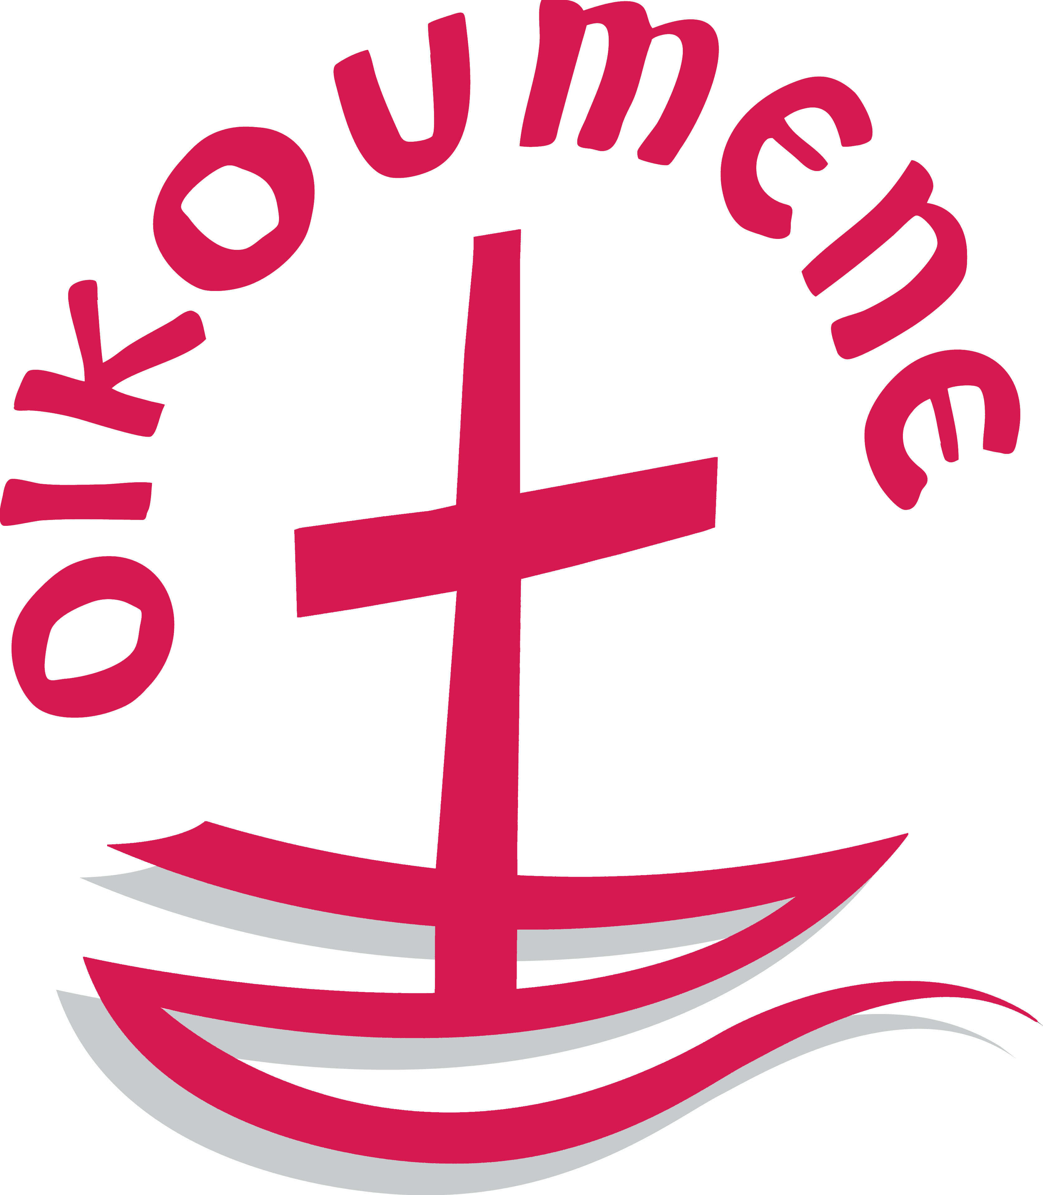
World Council of Churches
Youth Internship Programme
Geneva, Switzerland, February 2010 – January 2011

APPLICATION FORM
Deadline 30th September 2009
Please, type or print clearly!

Internship you are applying to:
1. International Ecumenical Peace Convocation
2. Youth and Ecumenical Formation 3. Visitors Program/Media Relations
4. Mission and Evangelism 5. Ecology and Social Justice

Family name/Surname(s) (as in passport)
First name/Given name(s) (as in passport)
Street Address Postal Code
Town Country
Please provide at least one fax number or one e-mail address where you can be reached for quick communication.
Home Telephone (country code / area code /number)
Office Telephone (country code / area code / number)
Telefax (country code / area code / number)
Office Telefax (country code / area code / number)
e-mail
Gender (as in passport) □ Male □ Female
Marital Status (for insurance purposes) □ Single □ Married
Indigenous Person □ Yes If yes, please specify your people/tribe/nation:
Date of Birth (day / month / year)
Denomination / Church Family:
Name of national Church from which you are member:
Profession or Occupation (if student, in which field):
Nationality (country issuing your passport):
Higher Education (College/University level)
Degree title:
Degree obtained or expected for (month / year)
Study started (month / year):
Major subject of study:
University/Institute:
City: Country:

Higher education (cont'd.)
Degree title:
Degree obtained or expected for (month / year)
Study started (month / year):
Major subject of study:
University/Institute:
City: Country:

Language skills:
Mother Tongue:
 | Reading  Very Good / Good / Basic | Writing  Very Good / Good / Basic | Speaking  Fluent / Good / Basic
English:
French:
German:
Spanish:
Other:

Computer Skills:

Please don't forget to enclose:

- Short CV (maximum 2 pages)
- Copy of a letter of recommendation from your church/ regional ecumenical organisation
- Copy of sending community application must be written by your church, ecumenical organization or Christian youth network etc
- Motivation letter

Please answer the following questions in your motivation letter:
- What is your involvement in your church or student Christian movement, ecumenical organization?
- Why are you interested in the ecumenical movement / becoming a WCC intern?
- Have you ever been involved in youth work at a local, national or international level?
- How can you further ecumenical work in your local or national situation?
- Describe yourself (personality, values, and life experience).
- What is your idea for the ecumenical project that you will start at home and work on together with your church or ecumenical organization starting from February 2011?
* Please write between 1-2 paragraphs in response to each question

Only applications which are fully completed, accompanied with the mentioned enclosures and received on time will be considered. Applications should be submitted by e-mail if possible, or by fax or mail. Your referees can send their recommendation letters directly to us (by e-mail or fax) if they prefer to do so. Due to the number of applications received, acknowledge of receipt is not possible. Thanks for your comprehension.
Send your application to: | World Council of Churches  Youth Internships Programme  150, route de Ferney - PO Box 2100  1211 Geneva 2, Switzerland  Tel: +41 22 - 791 6315  Fax: +41 22 - 791 6406  e-mail: wccinterns@gmail.com

E-mail: LSM@wcc-coe.org

Special note for US applicants: Due to postal charges, we DO NOT accept express US Airmail courier. You can send your application by fax or e-mail if you want to be sure not to miss the deadline. Thank you for your understanding

